WESTERN PACIFIC UNIVERSITY
CMN224 / CMP224 Software Engineering — Week 5

Lab 4: Architecture & UML for Your Client
Formative (ungraded) · Moodle-enabled · output is the first half of Task 4 (15%, due Week 11)
Item | Details
Linked to | Week 5 lecture — Designing Software Architecture with UML (ULO2, ULO4)
Work mode | Individually, on the SAME client you chose for Task 2
Time | About 90 minutes
Tools | diagrams.net desktop OR PlantUML — both free, both work offline, both cached on Moodle
Submission | Diagrams + this worksheet to Moodle AND committed to week05/ in your Git portfolio
Do this properly and Task 4 gets much easier. Task 4 (Design & Modelling Deliverable, due Week 11) asks for an outline architecture plus UML models. The two diagrams you produce today are exactly that architecture section. Weeks 9–10 add the behavioural diagrams.

Part A — Answer the six design questions (25 min)
Answer for YOUR client (Kina Ridge Primary School or Waghi Valley Produce Cooperative). One or two sentences each — but each answer must be a decision, not a description.
Kina Ridge Primary School
# | Question | Your decision, and the requirement that forced it
1 | What are the major parts of the system? | The major parts of the system of Kina Ridge Primary School split into fee intake, arrears tracking, receipt generation, and reporting modules. The board demands arrears visibility and trustworthy receipts, so this functions must be distinct and reliable.
2 | How do the parts communicate? | Modules communicate through a shared local database with controlled interfaces. The bursar and assistants must update records consistently, avoiding mismatched reports from Excel sheets.
3 | Where does the data live? | All data lives in a single local database on the office laptop, with backup to external drive. Weekly power cuts and limited infrastructure mean cloud hosting is too risky; local persistence is mandatory.
4 | Where does each part physically run? | The system runs on the office laptop, with reports printed locally. Only one laptop and printer exist; deployment must match available hardware.
5 | How is access controlled, and where is that enforced? | Enforced by role-based login at the application level. The bursar, assistants, head teacher, and board need different privileges — receipts, summaries, reports.
6 | What happens when it fails — power loss, no signal, duplicate sync? | On power loss, the system saves state locally and resumes on restart; duplicate sync is flagged for manual resolution. Frequent outages and instalment payments make resilience essential to prevent lost or duplicated records.

Part B — Choose an architectural pattern (10 min)
Pattern chosen (or blend): Layered Architecture
In 100–150 words: why this pattern for THIS client? Name one pattern you rejected and the specific requirement that ruled it out.
For Kina Ridge Primary School, a layered architecture is most suitable because it separates concerns into clear tiers: data storage, business logic, and presentation. This ensures fee intake, arrears tracking, receipt generation, and reporting remain modular and maintainable. The bursar and assistants interact through the presentation layer, while the business logic enforces rules for arrears and receipts, and the database layer ensures consistent records. This pattern directly addresses the requirement for trustworthy receipts and clear arrears visibility, while also supporting resilience against frequent power outages by keeping all data locally stored.
A client–server pattern was rejected because it depends on reliable connectivity, which is not feasible given the school’s weekly power cuts and limited infrastructure. Local resilience and simplicity outweigh distributed access in this context, making layered architecture the pragmatic choice.
Warning: if you chose client–server with one central database, check it against your Part A question 6 answer. At a site with no reliable connectivity that choice fails on day one.

Part C — Draw the package diagram (25 min)
Show your system as 3–5 logical packages with dependency arrows. Rules: arrows point downward only; every package has one clear responsibility; no package is called “Miscellaneous”.

If you are using PlantUML, start from this
@startuml package "UI" { [Fee Entry Form]
}
package "Application Logic" {
[Fee Service]
}
package "Data Access" {
[Payment Repository]
}
[Fee Entry Form] --> [Fee Service]
[Fee Service] --> [Payment Repository] @enduml
Save as week05/architecture-packages.puml (or .drawio from diagrams.net).
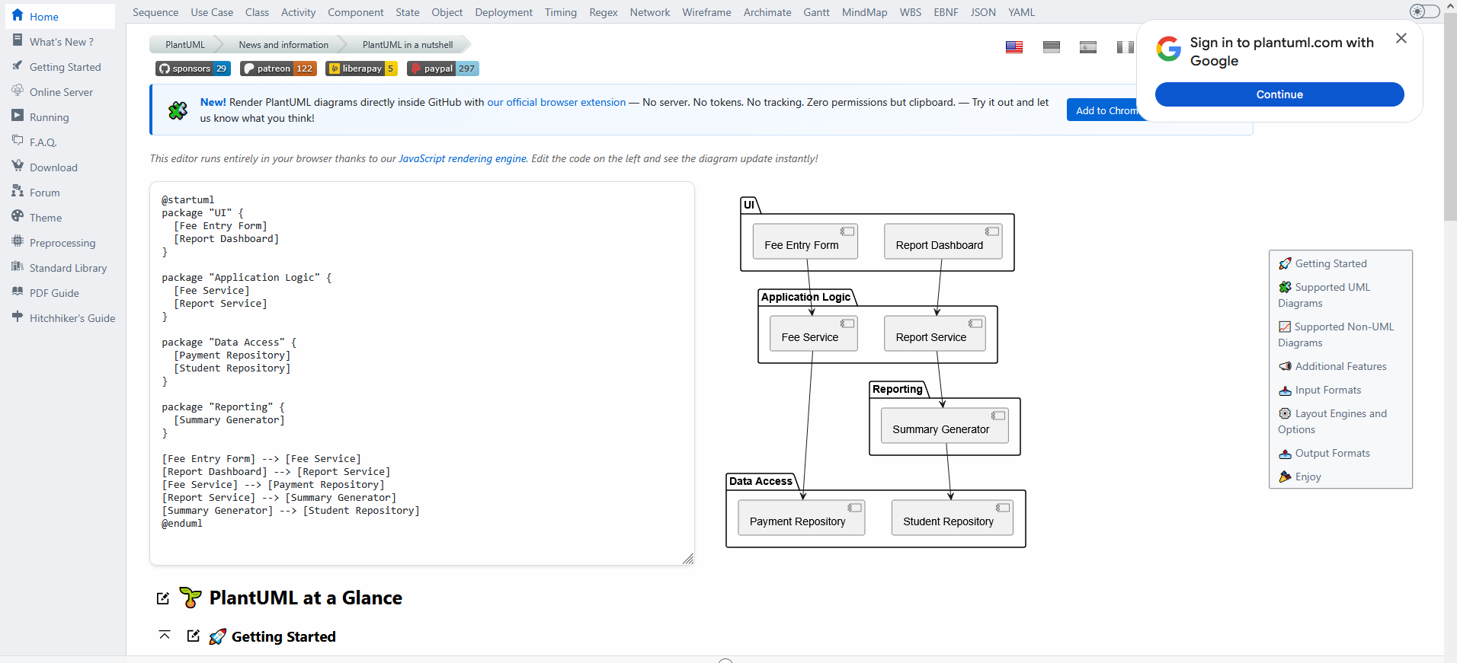
Figure 1.1. Architecture-packages diagram snapshot of the diagram on Plant UML.

Part D — Draw the deployment diagram (25 min)
Show every device your system runs on, what is installed on each, and the link between them. This is the diagram that exposes PNG delivery risk, so be honest about the network.
Must appear on your diagram | Check
Every physical device (laptop, phone, office PC, printer) | Write down every device the system actually uses:  - Laptop (office bursar’s laptop)  - Office PC (administration computer)  - Phone (optional, if staff use mobile intake)  - Printer (for receipts/reports)
What software component sits on each device | For each device, specify what runs there:  - Laptop → Fee Intake App + Local SQLite database  - Office PC → Consolidation App + Master Database  - Phone → Mobile Intake App (if used)  - Printer → Receipt/Report output (no software, but connected to laptop/PC)
Where the data is stored on each device | - Laptop stores local transactions in SQLite.  - Office PC stores master records in the central DB.  - Phone stores temporary intake records until synced.  - Printer stores nothing — it just prints.
The link between devices, labelled with how and how  often it is available | - Laptop ↔ Office PC: USB transfer or 4G sync when available  - Phone ↔ Laptop: Bluetooth or offline sync when signal returns  - Laptop ↔ Printer: Direct USB or local network printing
A note on what still works while that link is DOWN | - If Laptop ↔ Office PC link is down → laptop still records fees locally.  - If Phone ↔ Laptop link is down → phone still records intake offline.  - If Printer link is down → system still tracks fees, but receipts cannot be printed until restored.

PlantUML deployment starter
@startuml
node "Depot laptop" { [Intake App]
database "Local SQLite"
}
node "Town office PC" { [Consolidation] database "Master DB"
}
[Intake App] ..> [Consolidation] : USB or 4G when available
@enduml

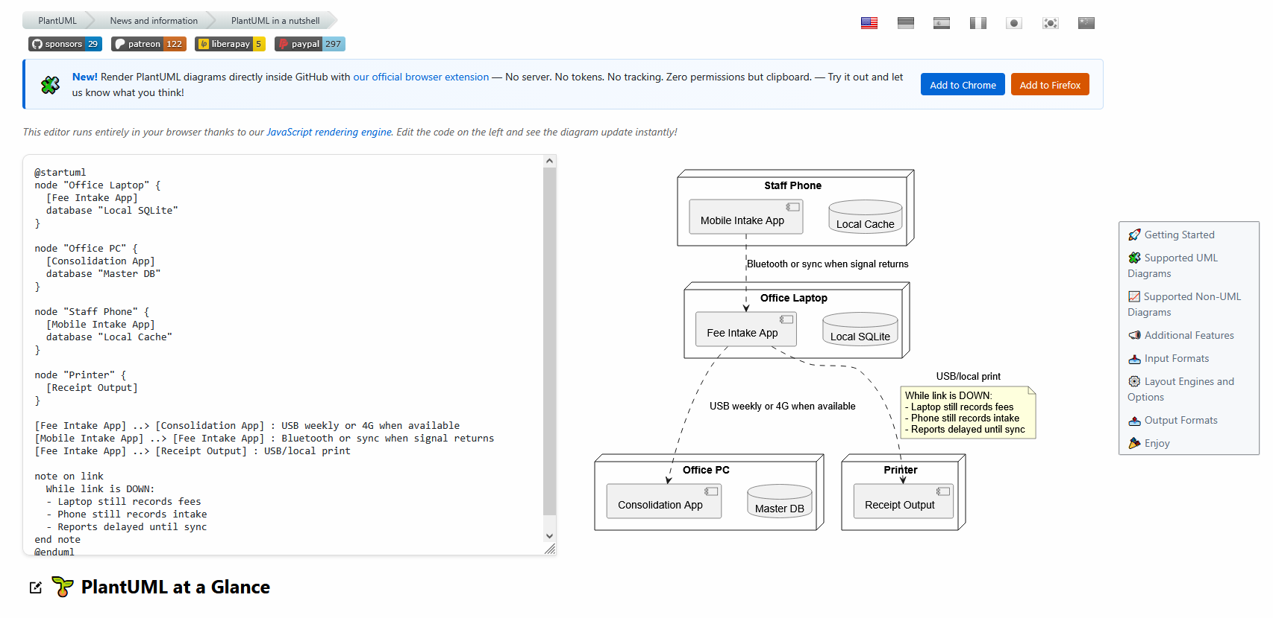
Figure1.2. Architecture-deployment snapshot of the diagram on Plant UML

Part E — Commit (5 min)
- Put both diagram files and this worksheet into week05/ in your portfolio.
- Commit with a message that says what you decided, not just what you added:
git add week05/ git commit -m "Add offline-first architecture: package and deployment diagrams"
AI use: you may use AI to draft PlantUML text. You must then check it against your own Part A answers — generated architectures default to cloud client–server and routinely ignore power loss and duplicate sync. Declare AI use in your README.

